**Definitions:**

1. ISP* is the vacuum impulse that would be obtained by a sonic nozzle in air-breathing motor work, and thus may be ignored.
2. C* is the Characteristic Exhaust Velocity (cee-star), with units of feet/sec. This parameter may be considered to be a figure of thermochemical merit for a particular propellant. It is given by

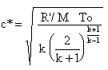

Where k is Cp/Cv, T0 is Chamber Temperature,

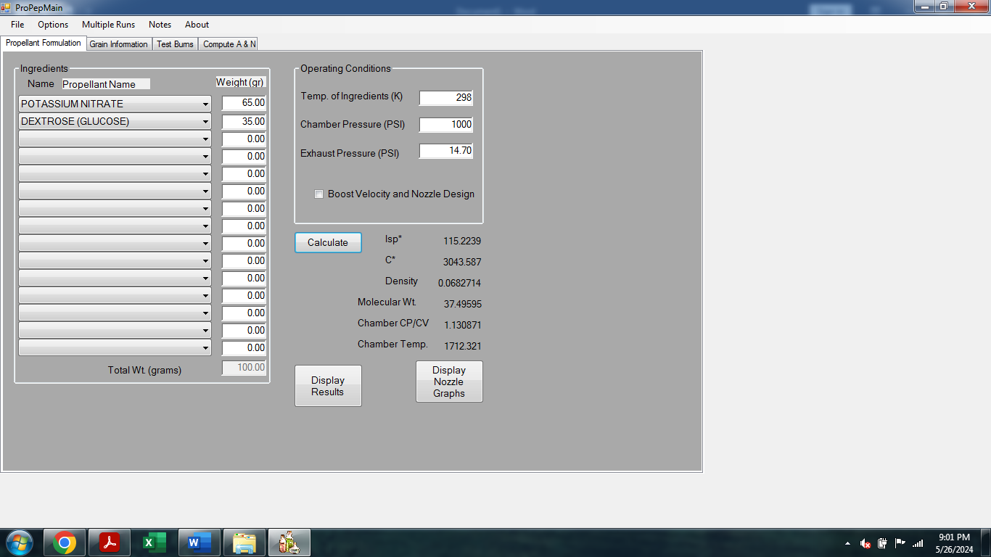**KNDX – 65:35**

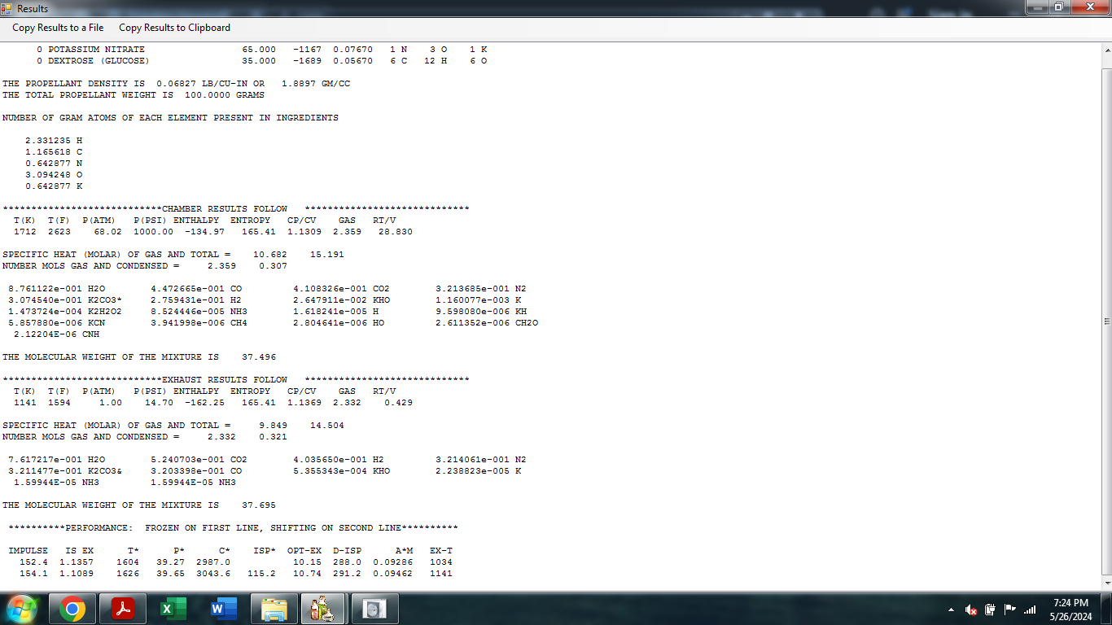

* **Chamber Temperature:** 1712K or 2623F
* **Cp/Cv**: The ratio of specific heats, k, for the mixture at combustion chamber conditions, this is correct value to use when calculating characteristic velocity (cee-star) and chamber pressure. It is given by

 where

Cp/Cv is 1.1309.

* **Enthalpy:** -134.97J/Kg
* **Entropy:** 165.41J/K

**KNSU - 65:35**

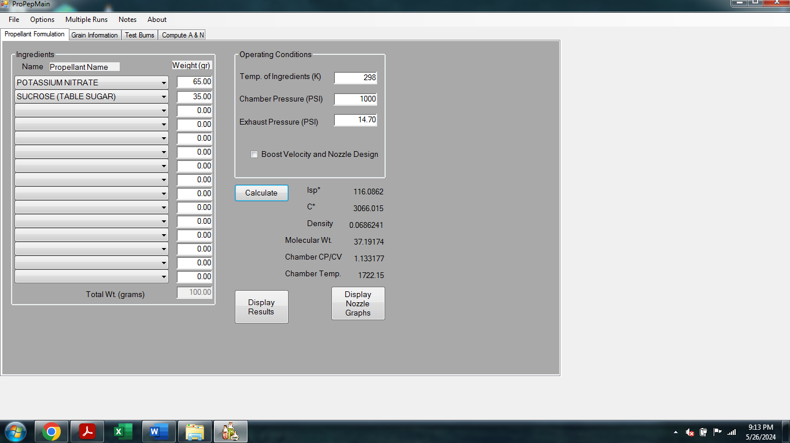

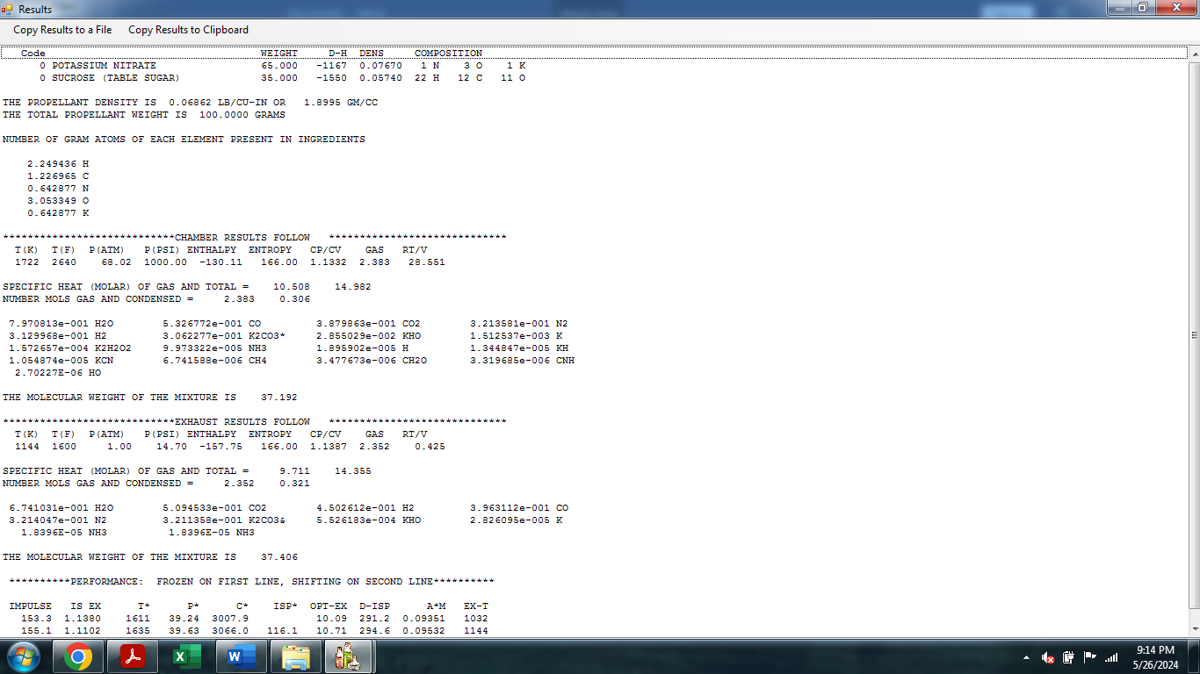

* **Chamber Temperature:** 1722K or 2640F
* **Cp/Cv**: The ratio of specific heats, k, for the mixture at combustion chamber conditions, this is correct value to use when calculating characteristic velocity (cee-star) and chamber pressure. It is given by

 where

Cp/Cv is 1.1332.

* **Enthalpy:** -130.11J/Kg
* **Entropy:** 166J/K

**KNDX + Al 65:20:10**

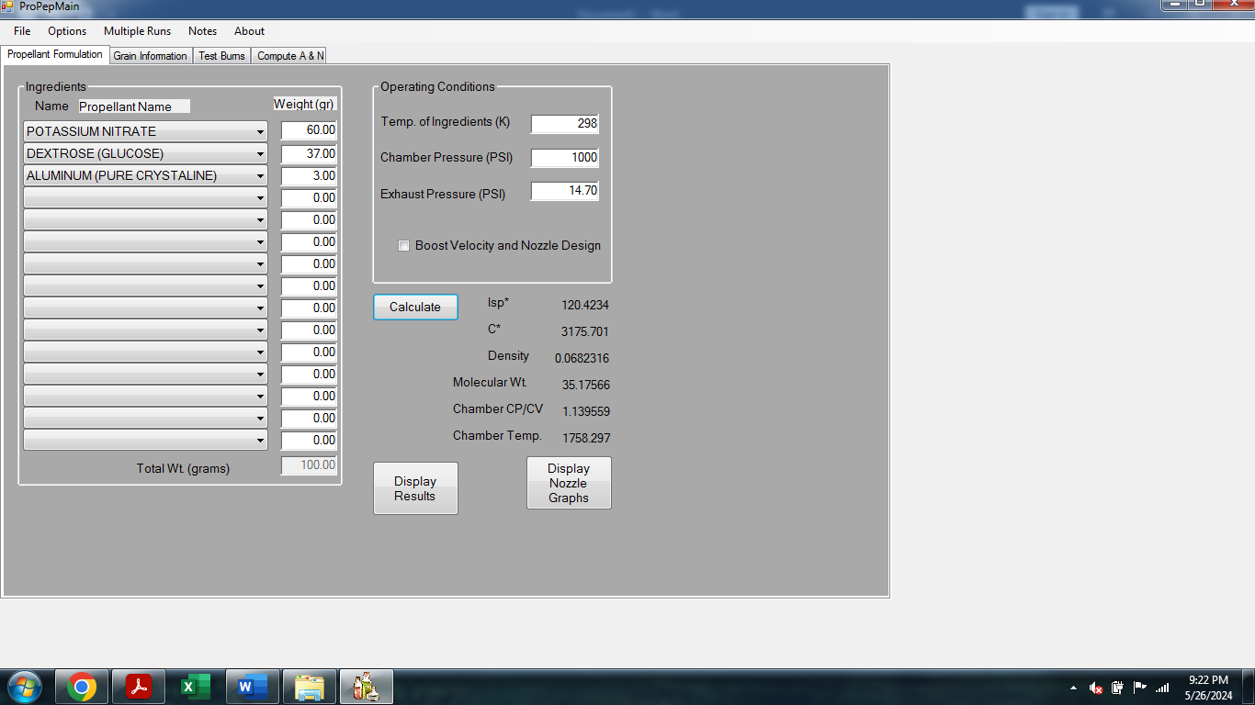

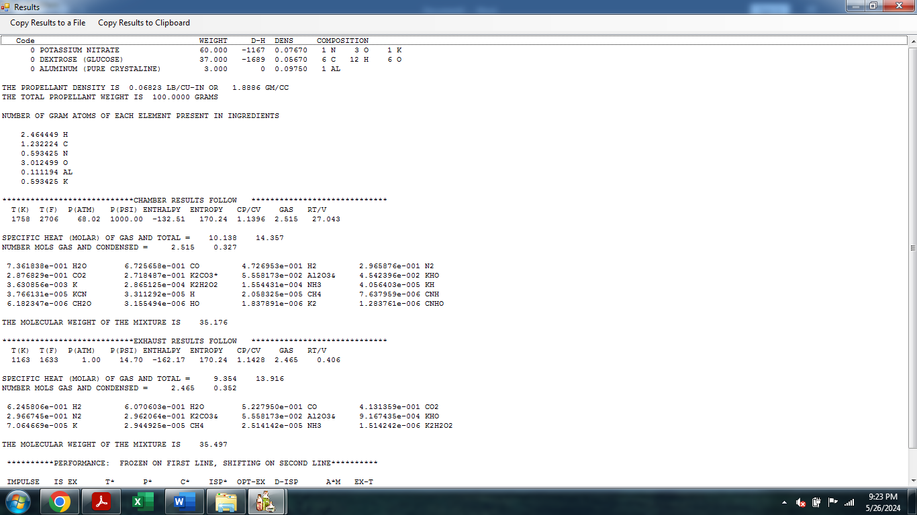

* **Chamber Temperature:** 1758K or 2706F
* **Cp/Cv**: The ratio of specific heats, k, for the mixture at combustion chamber conditions, this is correct value to use when calculating characteristic velocity (cee-star) and chamber pressure. It is given by

 where

Cp/Cv is 1.1396.

* **Enthalpy:** -132.51/Kg
* **Entropy:** 170.24J/K

**KNDX + Iron Oxide 60:30:10**

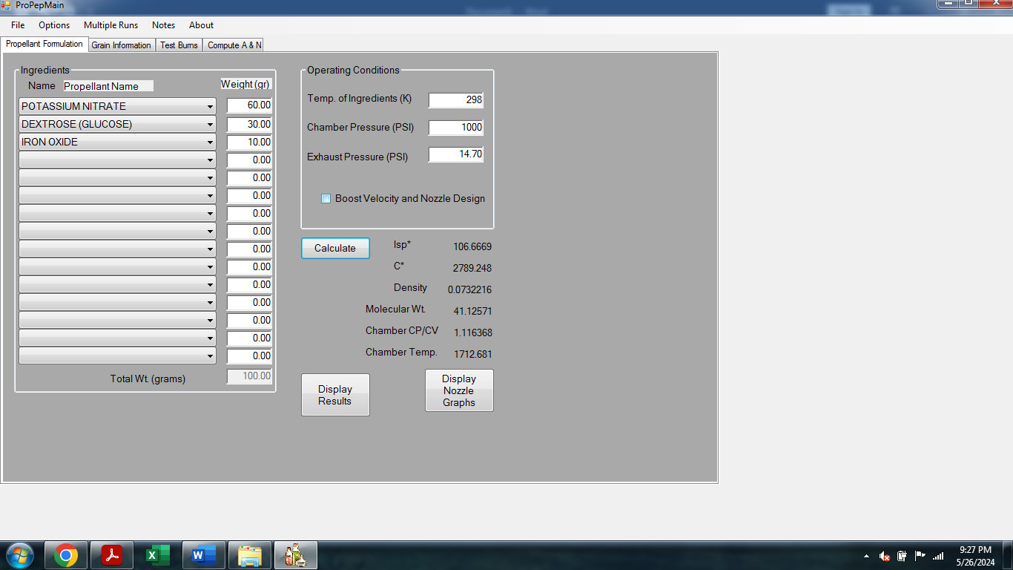

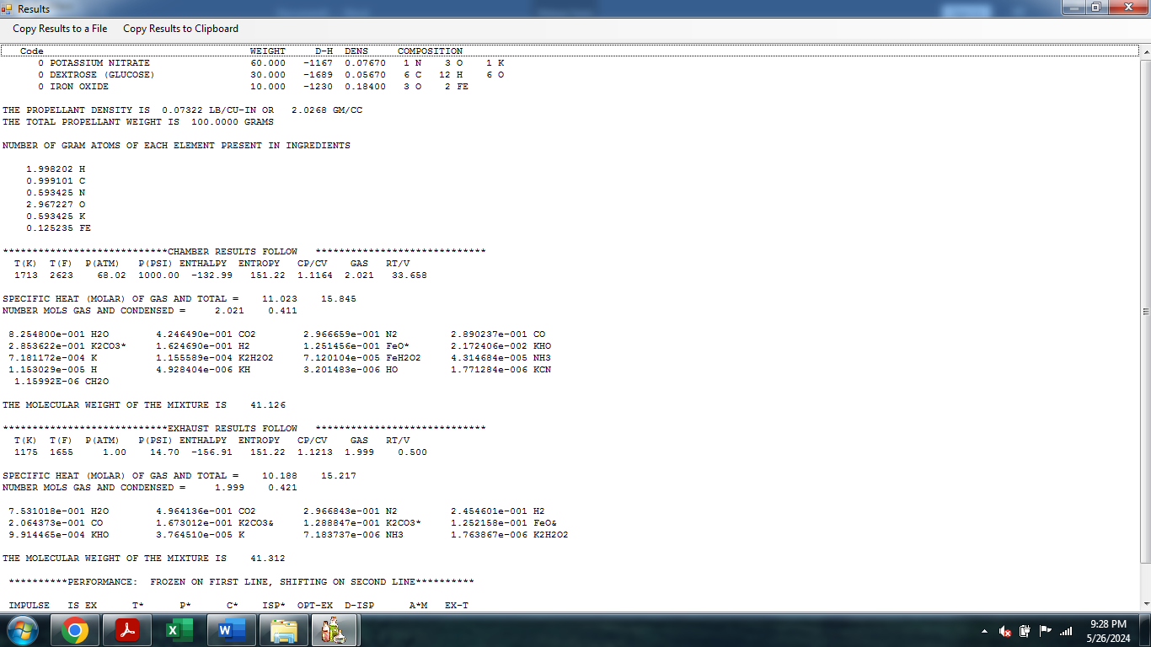

* **Chamber Temperature:** 1713K or 2623F
* **Cp/Cv**: The ratio of specific heats, k, for the mixture at combustion chamber conditions, this is correct value to use when calculating characteristic velocity (cee-star) and chamber pressure. It is given by

 where

Cp/Cv is 1.1164.

* **Enthalpy:** -132.99/Kg
* **Entropy:** 151.22J/K